### Sailing Instructions

### for

### Open Meetings at WOSC

**1)** **Definitions**

Words in italics are either defined under this heading or in the Racing Rules of Sailing**.**

The *course board* is the blackboard situated in the garage.

The *official club notice board* is situated in the club foyer.

Instructions containing *shall* are deemed to be mandatory.

The *club main mast* is situated immediately in front of the RO box.

**2)** **Rules.**

*Racing* will be governed by the Racing Rules of Sailing (RRS) 2021-2024 (see <https://www.racingrulesofsailing.org/rules>), the prescription of the RYA, class rules and the bylaws of West Oxfordshire Sailing Club (WOSC) except as any of these are amended by these Sailing Instructions. The RRS will be changed as follows.

|  |  |
| --- | --- |
| RRS Number | Alteration |
| 27.1 | Course defined on the course board |
| 32.2 | Finishing line and shortening course redefined in section 11 |
| 40 | Flag Y will not be flown |
| A4 | 2 minute late start =DNS |
| 45 | Preparatory replaced by 1 minute before start |

**3)** **Entries.**

**3.1)** Entrants and authorised guests will be granted temporary membership of WOSC upon payment of entry fee for the period of theevent and shall comply with any Club Rules and bylaws.

**3.2)** The entry form is deemed to be the signing on form and only needs to be completed once for the duration of the race meeting.

**3.3)** Personal buoyancy shall be worn at all times by any person in or on any type of craft racing or otherwise. Competitors failing to comply with this rule will be subject to disqualification without a hearing. Self-inflating buoyancy aids are not permitted. Wetsuits and drysuits DO NOT constitute personal buoyancy. Flag Y will not be flown. This changes rule 40.

**4) Notices to Competitors**.

Notices to competitors will be posted next to the *course board*, and may also be announced during a pre-race briefing.

**5)** **Alterations to the Sailing Instructions.**

Any alterations to the Sailing Instructions will be posted next to the *course board* at least 30 minutes before the scheduled time of the warning signal. They may also be announced during a pre-race briefing.

**6)** **Signals made Ashore**.

**6.1)** Signals made ashore will be displayed on the *club main mast.*

**6.2)** Postponed races will be indicated with flag AP with two sound signals.

**6.3)** The warning signal will be made not less than 1 minute after AP is lowered.

**7)** **Class Flags**

Class flags will be defined on the *course board* if required.

**8)** **Racing Area**.

**8.1)** The *racing* area is shown in illustration A.

**8.2)** A boat *shall* not sail into the swimming area as defined in illustration A or make contact with any of the area buoys. This area *shall* be treated as an obstruction. A protest committee may disqualify any boat contravening this rule.

**9)** **Courses**.

**9.1)** The course will be displayed on the club *course board* at least 10 minutes before *racing* commences. It will be described both pictorially and listed by mark. The list *shall* take precedent. This amends rule 27.1.

**9.2)** The *marks*, may be a mixture of the fixed *marks* and any movable *marks* the Race Officer (RO) deems necessary in order to provide a reasonable course.

**10)** **The Start**.

**10.1)** *Racing* *shall* commence using rule 26, with the warning signal given 5 minutes before the relevant starting signal.

**10.2)** The start line may be either between the club main mast and a *mark*, or a mast on the committee boat and a *mark*. An inner distance mark may be used.

**10.3)** Boats whose warning signal has not been made shall avoid the starting area.

**10.4)** A boatstarting later than 2 minutes after her starting signal will be Scored Did Not Start (DNS) without a hearing. This alters rules A4.

**10.5)** Where an inner distance *mark* is laid in conjunction with the committee boat, a boat *shall* not pass between it and the committee boat after her preparatory signal, treating the area as an obstruction.

**11)** **The Finish**.

**11.1)** The finishing line may be any of the following.

A line between the club main mast and the post with a triangle on the eastern shore.

A line between the club main mast and any *mark* of the course.

A line between the committee boat mast and any *mark* of the course.

**11.2)** Only helmsmen retiring are required tosign a declaration on the signing on sheet after racing.

**11.3)** At the discretion of the RO a boat may be finished having completed less laps than the lead boat. Any boat finished in this manner can’t be placed ahead of boats that did complete the course, unless the race is defined as an average lap race in the notice of race.

**11.4)** The course ends at the finish line when the specified number of laps have been completed or when Flag S is flying.

**11.5)** For races which are designated as ‘average lap’ the ‘about to finish’ Flag shall be Flag ‘S’ accompanied by 2 sound signals which *shall* be flown as the leading boat of the race (or if more than one race is in progress any race) passes the last mark of the round, and she shall finish as she then crosses the line. All subsequent boats crossing the line shall then be finished.

**11.6)** Boats who have not finished within 20 minutes of the lead boat will be Scored Did Not Finish (DNF), and the race will be considered to have ended.

**11.7)** In the case of back to back races, the warning signal of the next race will be given at least 2 minutes after the previous race is ended (last boat finishing or 20 minutes elapsed, whichever occurs first).

**12)** **Protests**.

Protest forms are available from the Race Officer’s box.

Protests *shall* be delivered there within 30 minutes of the last boat’s finish in the relevant race, (or the last race if the races are sailed back to back).

**13) Hauling Out Making Fast: Anchoring restrictions.**

A boat shall be afloat and off moorings 1 minute before her starting signal. This alters rule 45

**14) Risk Statement**

Rule 4 of the Racing rules of sailing states:’ The responsibility for a boat’s decision to participate in a race or to continue racing is hers alone.” Sailing is by its nature an unpredictable sport and therefore inherently involves an element of risk. By taking part in the event, each competitor agrees and acknowledges that:

1. They are aware of the inherent element of risk involved in the sport and accept responsibility for the exposure of themselves, their crew and their boat to such inherent risk whilst taking part in the event;
2. They are responsible for the safety of themselves, their crew, their boat and their other property whether afloat or ashore;
3. They accept responsibility for any injury, damage or loss to the extent caused by their own actions or omissions;
4. Their boat is in good order, equipped to sail in the event and they are fit to participate;
5. The provision of a race management team, patrol boats and other officials and volunteers by the event organiser does not relieve them of their own responsibilities;
6. The provision of patrol boat cover is limited to such assistance, particularly in extreme weather conditions, as can be practically provided in the circumstances;
7. Their boat is adequately insured, with cover of at least £2million against third party claims.

.

**15)** **Boats and Competitors in Difficulties**

When the Race Committee or the Safety Boat Operative considers that a boat or competitor is in difficulties it may instruct the boat or competitor to accept outside help, retire or sail ashore.

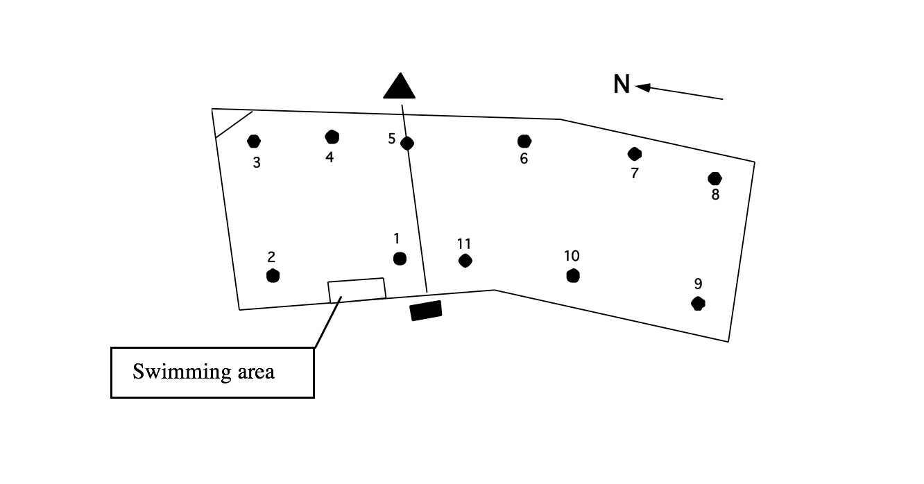

Illustration A